**Lab No.2**

**01. Write a C program that takes two integer values as input from the user. Then swap the values taken from the user and display the output of the variables.**

#include <stdio.h>

#include <stdlib.h>

int main()

{ **Out put:**

int firstNumber, secondNumber, temp;

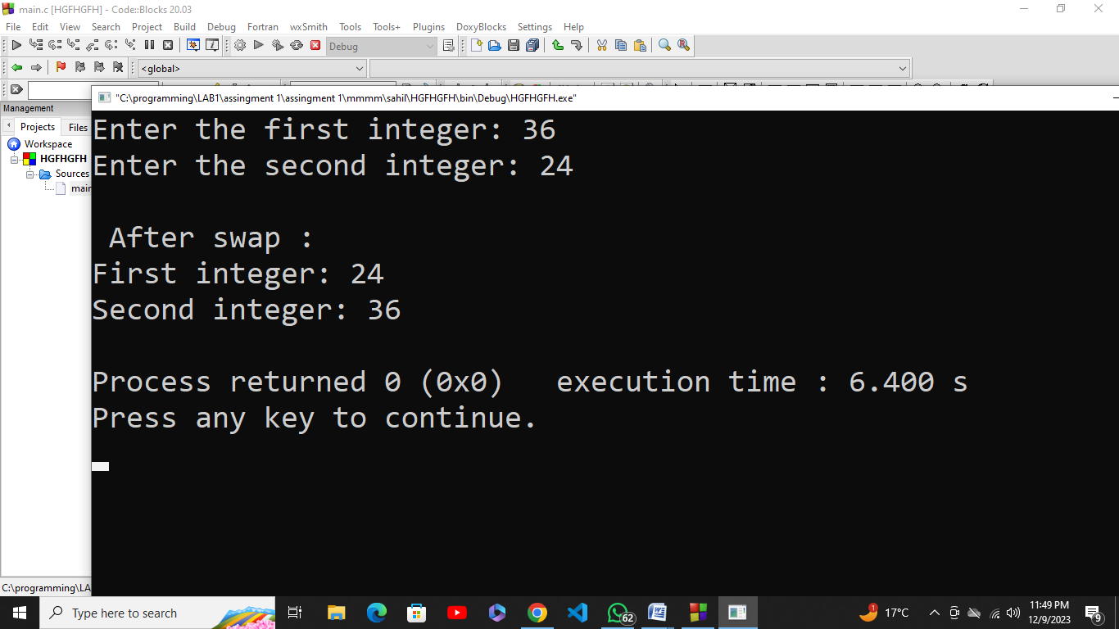

printf("Enter the first integer: ");

scanf("%d", &firstNumber);

printf("Enter the second integer: ");

scanf("%d", &secondNumber);

temp = firstNumber;

firstNumber = secondNumber;

secondNumber = temp;

printf("\n After swap :\n");

printf("First integer: %d\n", firstNumber);

printf("Second integer: %d\n", secondNumber);

return 0;

}

**02. A customer asks the IT firm to develop a program in C language, which can take tax rate and salary from the user on runtime and then calculate the tax, the user has to pay and the salary he/she will have after paying the tax. This information is then provided to the user.**

#include <stdio.h>

#include <stdlib.h>

int main() **Output:**

{

float taxRate, salary, tax, netSalary;

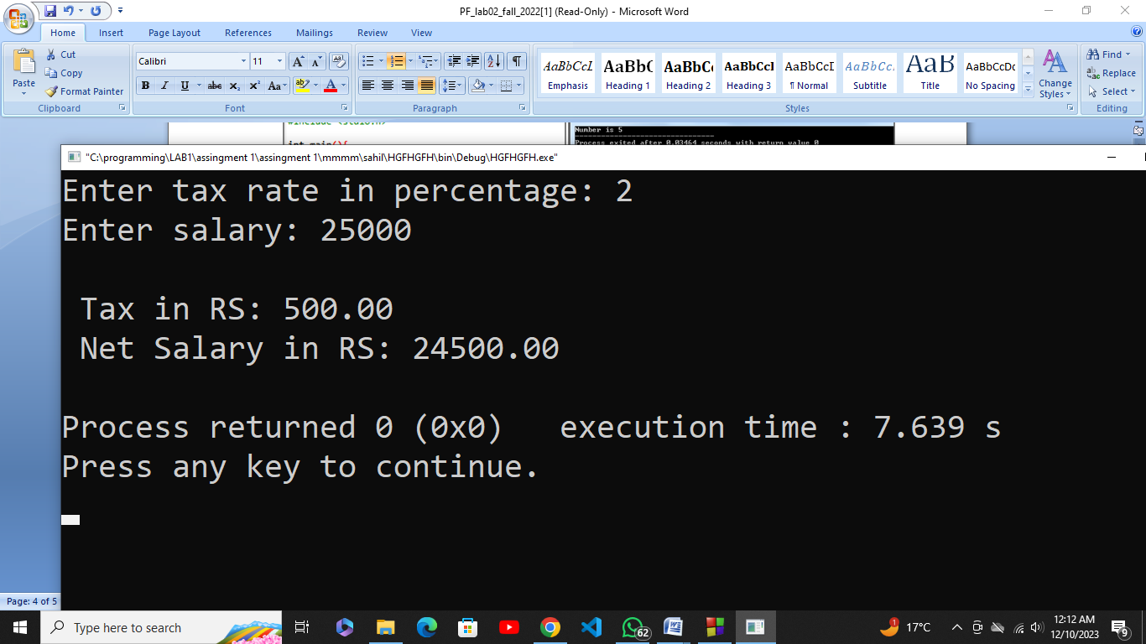

printf("Enter tax rate in percentage: ");

scanf("%f", &taxRate);

printf("Enter salary: ");

scanf("%f", &salary);

tax = (taxRate / 100) * salary;

netSalary = salary - tax;

printf("\n Tax in RS: %f \n Net Salary in RS: %f \n", tax, netSalary);

return 0;

}

**03. A car traveled for some hours. The time car traveled is taken at run time of the program, and it must not be negative and must be between one to five hours. The car had not traveled same distance in each hour. The distance that the car covered must not be negative. Write a C Program that computes the Average Speed of the Car in miles per hour. Hint: the restrictions can be displayed in the form of message on the window.**

#include <stdio.h>

#include <stdlib.h>

int main()

{

float time, distance, averageSpeed;

printf("Enter time traveled by the car 1 to 5 hours: ");

scanf("%f", &time); **Out put:**

if (time < 1 || time > 5)

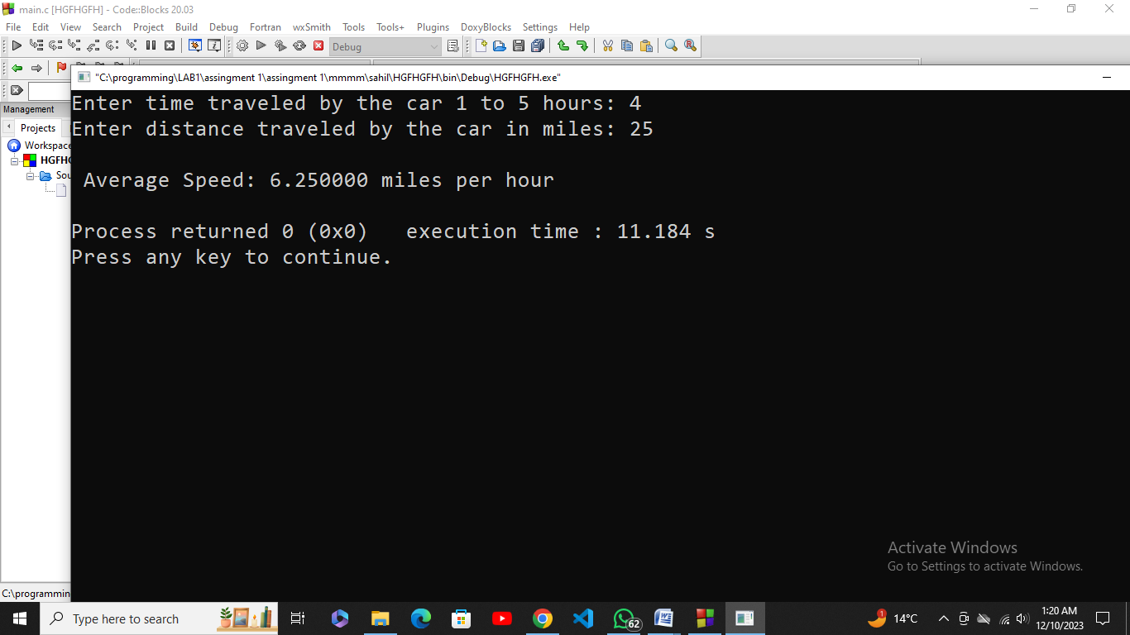

printf("Enter a value between 1 to 5 hours \n");

printf("Enter distance traveled by the car in miles: ");

scanf("%f", &distance);

if (distance < 0)

printf("Enter a non-negative number\n");

averageSpeed = distance / time;

printf("\n Average Speed: %f miles per hour \n", averageSpeed);

return 0;

}

**04. Explain the output of this C program. Why the wrong value is being displayed in the output?**

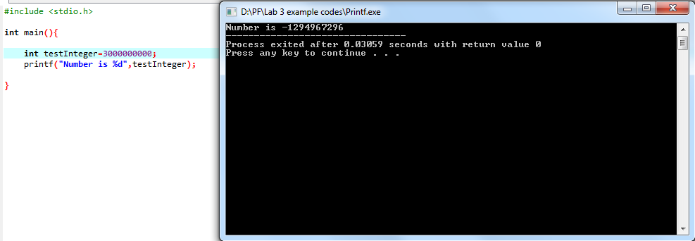

* The variable testinteger is declared as an int, which typically represents a 32-bit integer on many systems. The value you assigned 3000000000, exceeds the maximum value that can be stored in a 32-bit signed integer (**which is usually 2,147,483,647**).

**05. Construct a C program with the flowchart below. The input value of the Principle must be between 100 Rs. To 1,000,000 Rs. The Rate of interest must be between 5% to 10% and Time Period must be between 1 to 10 years. Hint: these restrictions can be displayed in the form of message on the window.**

#include <stdio.h>

#include <stdlib.h>

int main() {

int tp, p;

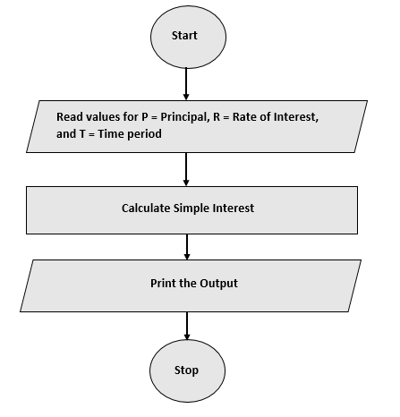float ri, si;

printf("Principle Value Must Be 100 to 1,000,000.\n");

printf("Enter The Value Of The Principle: \n");

scanf("%d", &p);

if(p>=100 && p<=1000000){

printf("Rate Of Interest Must Be 5 to 10 Percentage.\n");

printf("Enter Rate Of Interest : \n");

scanf("%f", &ri);

if(ri>=5 && ri<=10){

printf("Time Period Must Be 1 to 10 Year.\n");

printf("Enter Time Period In Years : \n");

scanf("%d", &tp);

if(tp<=0 || tp>10){

printf("Your Entered Time Period is Invalid \n");

return 0;

}

}else {

printf("YourEntered Rate Of Interest is Invalid \n");

return 0;

}

si = (tp*p*ri)/100;

}else {

printf("Your Entered Value Of Principle is Invalid \n");

} **Out put:**

printf("Simple Interest Rate = %.4f", si);

return 0;



